1. Introduction

2. Exploratory analysis

2.1 Data structure and baseline description
The study database comprised 1,253 patients diagnosed with Alzheimer’s disease who were followed annually for six years after diagnosis across twenty clinical centres. For each participant, repeated measures of behavioural and psychiatric symptoms (BPRS) were collected together with two cognitive scales (BPRS and CDRSB) and two imaging biomarkers (ABPET and TAUPET). Baseline covariates included age, sex, education level, body mass index (BMI), monthly income, employment status, activities of daily living (ADL), and residence type (WZC = 1 for nursing-home resident, 0 for community dwelling).
Importantly, no baseline covariates contained missing values, ensuring that all 1,253 individuals could be retained in subsequent longitudinal analyses.
All continuous baseline variables were summarized with appropriate precision—age, BMI, and income to zero decimals, and ADL, BPRS₀, CDRSB₀, ABPET₀, and TAUPET₀ to two decimals—while categorical variables were described by frequency and percentage. These summaries demonstrated wide variability across demographic and clinical factors.
Table 1 presents the baseline characteristics
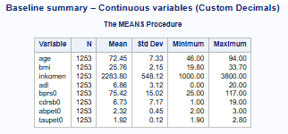
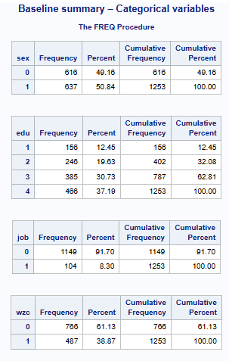
The original wide-format dataset, containing one record per subject, was reshaped into long format so that each row represents a patient-year observation. This structure retained all baseline covariates and allowed the modelling of within-subject correlation and time-dependent change.
In addition to the overall summaries, baseline behavioural status differed markedly by residence type. As shown in Figure 1, nursing-home residents (WZC = 1) had substantially higher BPRS₀ scores at diagnosis than community-dwelling participants (WZC = 0), with mean values of approximately 84.6 versus 69.6, respectively. The distributions were approximately normal in both groups but clearly shifted toward more severe symptoms among nursing-home residents, who also exhibited slightly greater variability. A two-sample t-test confirmed that this 15-point difference in baseline behavioural disturbance was highly statistically significant (p < 0.0001), indicating that institutionalised patients entered the study with a substantially greater neuropsychiatric burden than those living at home.
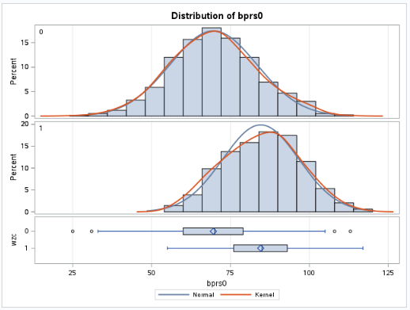
Figure 1. Baseline distribution of BPRS₀ by residence type (WZC). Histograms with overlaid normal and kernel density curves show that nursing-home residents (WZC = 1) have a right-shifted distribution of BPRS₀ and slightly greater spread compared with community-dwelling participants (WZC = 0). The corresponding t-test indicates a highly significant mean difference of about 15 points (p < 0.0001).

2.2 Mean structure and longitudinal trends
Figure 2 shows the population‐average trajectory of behavioural and psychiatric symptoms, measured by the BPRS, across the six years following an Alzheimer’s disease diagnosis. The mean BPRS increases in an almost perfectly linear fashion, beginning at roughly 75 points at diagnosis and rising consistently to just over 110 points by year six. This steady upward trend reflects a progressive and uninterrupted worsening of neuropsychiatric symptoms over time, with no visual indication of acceleration, deceleration, or temporary stabilisation. The linear shape of the curve suggests that patients experience a fairly uniform rate of deterioration, with BPRS scores increasing by approximately five to six points per year, a pattern that aligns well with the clinical course of the disease.
The shaded confidence interval surrounding the mean remains relatively narrow throughout the entire follow‐up period. This indicates that the estimated means are precise despite the reduction in sample size due to attrition at later visits. The slight widening of the interval over time reflects the gradual loss of participants but does not materially affect the stability of the estimated trend. The consistency of the confidence bands suggests that the population becomes more homogeneous in behavioural symptom severity as the disease progresses, an observation supported by the decline in the standard deviation over time.
Overall, the figure presents a clear and coherent depiction of behavioural deterioration in this cohort. The mean structure is smooth and strongly linear, showing no evidence of irregularities or changes in slope. These features support modelling approaches that treat time as a continuous linear effect and reinforce the conclusion that behavioural symptoms progress in a steady, predictable manner during the first six years following diagnosis.
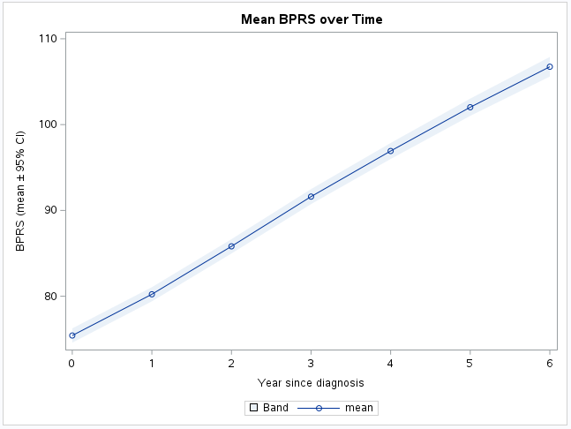
Figure 2. Population-average evolution of BPRS and corresponding variability over time. The mean BPRS exhibits an approximately linear increase across the six-year follow-up, whereas the standard deviation declines from baseline to year four and then stabilizes. This pattern reflects progressive behavioural deterioration combined with decreasing between-patient heterogeneity as the disease advances.
When stratified by residence, nursing-home residents consistently exhibited higher BPRS scores than community-dwelling participants at each annual measurement, reflecting a greater behavioural and psychiatric symptom burden already present at diagnosis. Nevertheless, the slopes of the two trajectories were almost parallel, implying that residence status influences the level of behavioural disturbance but not the rate of progression. In other words, nursing-home residents start from a more severe clinical position but deteriorate at a pace comparable to those living at home, a pattern consistent with an intercept difference without a time–by–residence interaction.
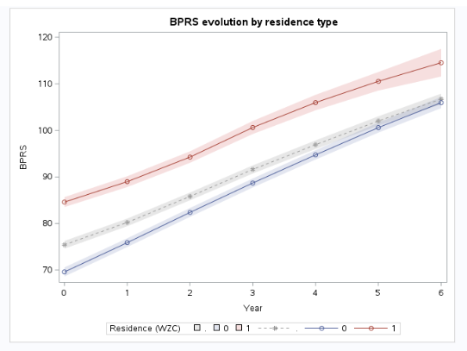
Figure 3. Mean BPRS trajectories over six years stratified by residence type (WZC). Nursing-home residents (WZC = 1) consistently exhibit higher behavioural and psychiatric symptom severity than community-dwelling participants (WZC = 0), while both groups follow approximately parallel linear trajectories. Shaded bands represent 95% confidence intervals around the estimated means.
A comparable pattern emerged when the trajectories were stratified by sex. Across all measurement occasions, female participants exhibited slightly higher mean BPRS scores than male participants, indicating a modest but persistent difference in behavioural and psychiatric symptom severity between sexes. Despite this difference in level, the shape of the trajectories was strikingly similar: both men and women showed a smooth and approximately linear increase in BPRS over the six-year follow-up. The two curves rose in parallel, with no visual indication of a divergence or crossover, suggesting that sex influences the overall magnitude of behavioural symptoms but not the rate at which those symptoms progress over time. This pattern is consistent with a mean structure characterised by a sex-specific intercept difference and a shared slope with respect to time. The overlap of confidence bands at later years further suggests that, although women display slightly higher symptom levels, individual variability within each sex remains substantial relative to the between-sex difference.
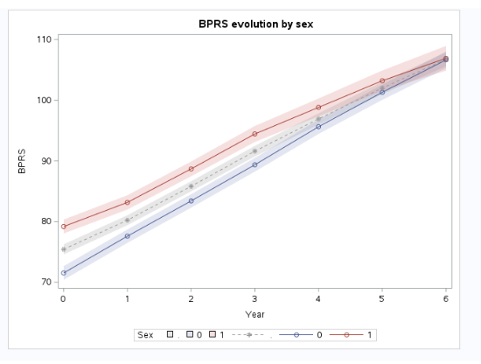
Figure 4. Longitudinal BPRS trajectories stratified by sex. Female participants (red line) consistently exhibited slightly higher mean BPRS scores than male participants (blue line) throughout the six-year follow-up period. Both trajectories increased in a nearly linear and parallel manner, indicating similar rates of behavioural deterioration across sexes. Shaded bands represent 95% confidence intervals around the estimated group-specific means.
Further insight into the role of initial behavioural status was obtained by stratifying patients according to their baseline BPRS₀ values. This analysis revealed two clearly separated trajectories. Individuals classified in the high-baseline group began the study with substantially elevated levels of behavioural and psychiatric symptoms and maintained this higher level at each subsequent measurement occasion. In contrast, patients in the low-baseline group exhibited consistently lower BPRS scores throughout the entire follow-up period.
Despite these pronounced level differences, the two trajectories rose in an almost perfectly parallel fashion. Both groups demonstrated a smooth, approximately linear increase in BPRS from diagnosis to year six, and no visual evidence of divergence or convergence between the two lines was observed. This indicates that baseline behavioural severity primarily affects the intercept of the trajectory rather than the slope. In other words, patients who enter the study with more severe behavioural symptoms do not deteriorate at a faster pace; instead, they remain uniformly more symptomatic over time. The narrow confidence bands around both groups suggest that the estimated trajectories are stable and that between-subject variability within each group remains moderate relative to the group-level separation.
This pattern is consistent with a model in which baseline behavioural severity acts as a strong determinant of overall symptom burden but does not modify the rate of behavioural decline. Accordingly, inclusion of BPRS₀ as a fixed-effect covariate in the mean structure is warranted, while an interaction between time and baseline group is unlikely to contribute meaningful additional explanatory power.
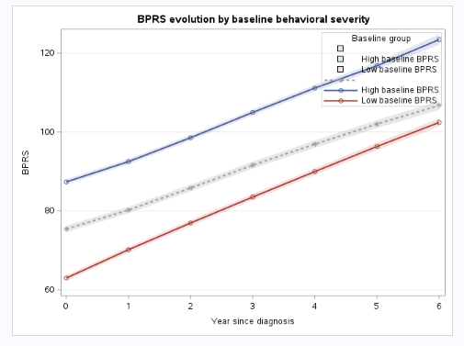
Figure 5. Longitudinal evolution of BPRS stratified by baseline behavioural severity. Patients with high baseline BPRS₀ values (blue line) exhibited substantially higher behavioural and psychiatric symptom levels throughout the six-year follow-up compared with those in the low-baseline group (red line). Both groups showed smooth and nearly parallel linear increases in BPRS, indicating that baseline behavioural severity influences the overall level of symptoms but not the rate of deterioration. Shaded bands represent 95% confidence intervals around group-specific mean estimates.
2.3 Individual heterogeneity
Inspection of individual patient trajectories provided further insight into the substantial heterogeneity underlying the population-average trends. When plotting a random subset of subjects, most individuals exhibited clear, monotonically increasing BPRS profiles, consistent with progressive behavioural deterioration following diagnosis. However, the trajectories differed markedly in both their starting levels and their rates of increase. Some patients began with relatively mild symptoms and showed gradual progression, whereas others started at substantially higher levels and experienced more pronounced year-to-year increases. A few trajectories rose steeply over a short period, while others progressed more moderately, highlighting the broad spectrum of behavioural decline across the cohort.
This visual heterogeneity reflects important between-subject variability that cannot be captured by fixed-effects models alone. The differences in intercepts suggest that patients enter the study with distinct baseline levels of behavioural disturbance, while the variability in slopes indicates that the speed of deterioration varies meaningfully between individuals. These features underscore the necessity of a mixed-effects framework with both random intercepts and random slopes to appropriately model subject-specific deviations from the population-average trajectory. Such a model structure is essential for capturing the full complexity of individual disease progression and for producing valid inferences in the presence of diverse clinical presentations.
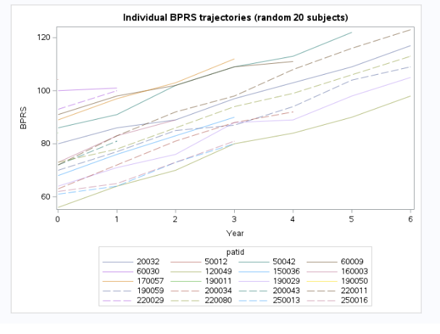
Figure 6. Individual BPRS trajectories for a random sample of 20 subjects. Each line represents the longitudinal evolution of behavioural and psychiatric symptom severity for one patient across the six-year follow-up period. Most trajectories display a monotonic increase, indicating progressive worsening over time, but the curves differ substantially in both baseline level and rate of progression. This pronounced between-subject heterogeneity supports the use of mixed-effects models with random intercepts and slopes to capture individual variability in symptom trajectories.
A comprehensive view of the full dataset was obtained by plotting all individual BPRS trajectories simultaneously. The resulting “spaghetti plot” revealed a dense bundle of upward-sloping lines, each representing the behavioural progression of a single patient across the follow-up period. Despite the visual complexity inherent to plotting over a thousand trajectories in a single figure, a clear overarching pattern emerged: nearly all patients demonstrated a steady increase in BPRS over time, confirming the general trend of behavioural deterioration observed in the population-level summaries.
The spread of the trajectories at baseline was substantial, reflecting considerable heterogeneity in initial behavioural symptom severity. As time progressed, however, the broad cloud of trajectories appeared to narrow slightly, consistent with the observed decline in the standard deviation of BPRS over time. This may represent a convergence toward more uniformly elevated symptom levels as the disease advances, combined with selective dropout among the most severely affected individuals. The spaghetti plot vividly illustrates the dual nature of the longitudinal structure: strong within-subject consistency (nearly all trajectories slope upward) combined with marked between-subject variability (wide range of intercepts and diverse slopes). These features reinforce the need for a modelling framework that incorporates both random intercepts and random slopes to capture the full range of individual-specific patterns.
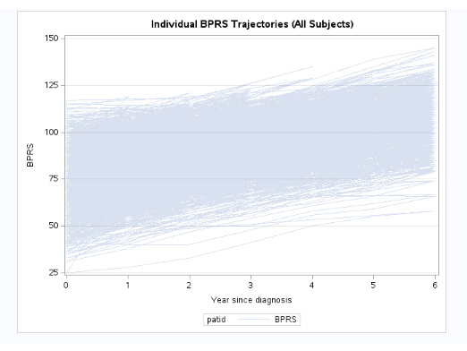
Figure 7. Full set of individual BPRS trajectories across all subjects. Each line represents the longitudinal evolution of behavioural and psychiatric symptom severity for a single patient over the six-year follow-up. The dense upward pattern illustrates consistent within-subject deterioration, while the wide spread of trajectories highlights substantial between-subject variability in both baseline severity and rate of progression.

2.4 Variance and correlation structures
An examination of the mean and variability of BPRS across time revealed a striking pattern in the dispersion of scores. While the mean BPRS increased steadily and almost linearly throughout the six-year follow-up, the standard deviation decreased markedly from approximately seventeen points at baseline to around thirteen by year four, after which it stabilised. This pattern indicates that the repeated measurements of BPRS exhibit clear heteroscedasticity, with greater variability early in the disease trajectory and a gradual convergence of symptom levels at later stages.
From a clinical perspective, the high variability at baseline reflects substantial heterogeneity in behavioural symptom severity at the time of diagnosis, with some patients presenting with relatively mild symptoms and others showing substantial behavioural disturbance. As the disease progresses, however, symptom severity becomes more uniformly elevated across individuals, leading to reduced between-subject variability. This may reflect both the natural tendency of Alzheimer’s disease to progress toward more severe behavioural impairment, and the selective dropout of individuals with extreme symptom levels, particularly those with very high baseline BPRS who were shown to discontinue follow-up earlier.
Statistically, this downward trend in variability underscores the need for modelling approaches that do not assume constant residual variance over time. The heteroscedasticity observed here is incompatible with simple structures such as compound symmetry and instead supports the use of heterogeneous covariance patterns—such as ARH(1) or Toeplitz-H—in subsequent mixed-effects models. These structures permit the residual variance to differ across time points while preserving the autoregressive decay in correlation documented in the correlation analysis.
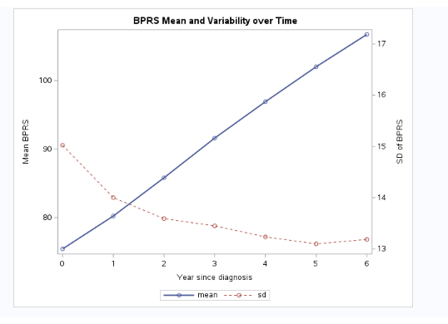
Figure 8. Population-average evolution of BPRS and corresponding variability over time. The mean BPRS exhibits an approximately linear increase across the six-year follow-up, whereas the standard deviation declines from baseline to year four and then stabilizes. This pattern reflects progressive behavioural deterioration combined with decreasing between-patient heterogeneity as the disease advances.
The correlation matrix of repeated BPRS measurements across the seven annual time points reveals a highly structured pattern of within-subject dependence. All correlations are extremely high, ranging from 0.93 to 0.99 for adjacent years and remaining above 0.80 even for measurements separated by six years. For example, the correlation between BPRS₀ and BPRS₁ is approximately 0.98, and between BPRS₀ and BPRS₆ it remains 0.91, indicating that patients’ relative behavioural severity is strongly preserved over time.
A key feature of the matrix is the monotonic decline in correlation as the temporal lag increases. Adjacent measurements (e.g., BPRS₃–BPRS₄ or BPRS₄–BPRS₅) consistently yield correlations around 0.97–0.98, whereas correlations between measurements separated by multiple years (e.g., BPRS₀–BPRS₅ or BPRS₁–BPRS₆) drop into the 0.89–0.93 range. This gradual decay is characteristic of an autoregressive process, in which the correlation between observations depends primarily on the time interval between them.
The high correlations across time points also reflect the strong within-subject stability of behavioural and psychiatric symptom severity. Individuals who begin with higher symptom burden tend to retain their position relative to others as the disease progresses. This aligns with the individual-level trajectories observed earlier, where patients showed parallel worsening but rarely changed their ranking relative to the cohort.
Table 2. Pearson correlation coefficients between repeated BPRS measurements at baseline and years 1–6. The matrix shows uniformly high within-subject correlations, with adjacent-year correlations exceeding 0.95 and a gradual decline to approximately 0.90 for measurements separated by six years. This pattern indicates strong temporal dependence and supports the use of autoregressive covariance structures in subsequent mixed-effects models.

From a modelling perspective, such a pattern is incompatible with simpler covariance structures that assume constant correlation (e.g., compound symmetry). Instead, the steadily declining values strongly motivate the use of AR(1) or ARH(1) covariance structures in mixed-effects modelling. The heterogeneous autoregressive structure (ARH(1)) is particularly appropriate here, as it allows both the decaying correlation and declining variance observed in the exploratory analyses to be captured simultaneously. This covariance model will permit more accurate estimation of fixed effects and more reliable inference in the presence of strong, lag-dependent correlation.

2.5 Missingness and dropout
Attrition was substantial over the six-year follow-up period, and the pattern of missingness followed a clear monotone structure. At baseline, all participants contributed a BPRS measurement; however, the proportion of observed values declined steadily at each subsequent visit, falling below 80% by year 2, approaching 60% by year 4, and reaching approximately 40% by year 6. This gradual and near-linear decline indicates that dropout accumulated progressively across the follow-up period rather than occurring at discrete points or in response to specific events or design changes.
The shape of the dropout curve is clinically plausible in the context of Alzheimer’s disease. As behavioural and cognitive symptoms worsen, participants often face increasing barriers to continued study participation, including institutionalisation, reduced caregiver availability, and declining functional capacity. This is consistent with additional analyses showing that patients with more severe behavioural symptoms at baseline—and those residing in nursing homes—tended to leave the study earlier, while baseline cognitive scores (CDRSB₀) did not predict dropout. These findings imply that the missingness mechanism is not consistent with missing completely at random (MCAR). Instead, dropout is related to observable baseline characteristics, aligning more with a missing-at-random (MAR) mechanism, under which likelihood-based mixed modelling remains valid.
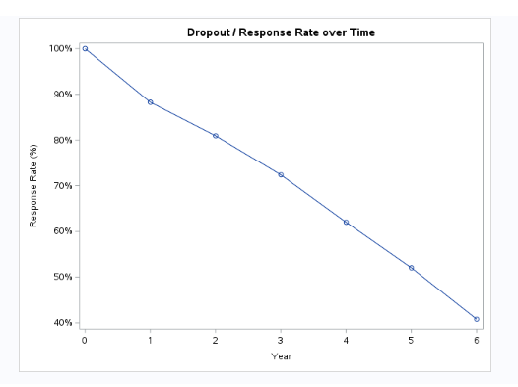
Figure 9. Proportion of subjects with observed BPRS measurements at each year of follow-up. The response rate declines monotonically from 100% at baseline to approximately 40% by year six, indicating substantial and progressive attrition. The smooth descent suggests gradual dropout over time rather than event-driven loss, consistent with a monotone missingness pattern that must be accounted for in the subsequent modelling framework.
The decreasing response rate also has implications for the interpretation of summary curves at later time points. Since patients with milder baseline symptoms tend to remain in the study longer, later-year averages likely reflect a somewhat more resilient subset of the cohort. This selective retention can result in underestimation of variability or bias in the shape of the mean trajectory if not properly accounted for. Together, these observations underscore the importance of using modelling approaches capable of handling unbalanced longitudinal data and justifying the use of REML-based mixed-effects models in the subsequent analysis.
To further characterise the dropout mechanism, the association between subjects’ follow-up duration and their baseline severity was examined. A strong negative correlation was observed between baseline behavioural severity (BPRS₀) and the last year in which a subject contributed data (r ≈ –0.68, p < 0.0001), indicating that patients who entered the study with more severe behavioural symptoms tended to discontinue follow-up earlier. In contrast, baseline cognitive severity (CDRSB₀) showed no meaningful association with follow-up length (r ≈ –0.004, p = 0.28), suggesting that cognitive impairment at diagnosis did not contribute significantly to attrition in this cohort.
This behavioural–dropout association is clinically plausible: subjects with more severe behavioural disturbance are more likely to experience rapid decline, institutionalisation, or reduced capacity to participate, all of which impede long-term follow-up. The lack of association with cognitive severity implies that behavioural symptoms, rather than cognitive deficits, are the primary drivers of early withdrawal.
The influence of residence status on retention further supports these patterns. As illustrated in Figure 9, community-dwelling participants (WZC = 0) typically remained in the study for substantially longer than nursing-home residents (WZC = 1). The median follow-up among nursing-home residents was markedly shorter and displayed greater variability, reflecting the increased clinical fragility and care dependency in this subgroup. Together, these findings indicate that dropout is not random but depends systematically on observed baseline characteristics. This pattern is incompatible with a Missing Completely at Random mechanism and supports the assumption of Missing at Random (MAR) for the mixed-effects modelling that follows.
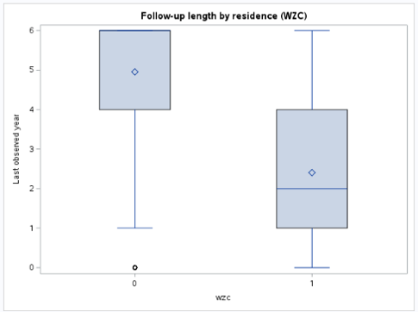
Figure 10. Follow-up duration by residence type (WZC). Community-dwelling participants (WZC = 0) generally remain under observation for substantially longer periods than nursing-home residents (WZC = 1). The shorter and more variable follow-up among nursing-home residents reflects greater clinical instability in this subgroup. These differences reinforce the observation that dropout depends on baseline behavioural and contextual characteristics.

2.6 Summary of exploratory findings
The exploratory analyses collectively provide a coherent picture of the behavioural and psychiatric progression in this Alzheimer cohort. Across the six-year follow-up, BPRS scores increased steadily and almost linearly, reflecting a continuous deterioration in behavioural functioning from the time of diagnosis. Subgroup comparisons indicated consistent differences in level but not in slope: nursing-home residents (WZC = 1) and female patients exhibited higher BPRS values at all time points, yet the rate of symptom escalation was similar to that of community-dwelling and male participants. When patients were categorised by baseline behavioural severity, those with initially high BPRS₀ scores remained at a higher symptom level throughout follow-up, again showing no evidence of a differential rate of change. These results suggest that baseline clinical status and demographic factors mainly influence the overall level of behavioural disturbance rather than its temporal progression.
The analysis of variability demonstrated that the standard deviation of BPRS decreased gradually over time, indicating heteroscedasticity in the repeated measurements. Correlation analysis revealed very strong within-subject associations between consecutive yearly observations, with correlations approaching 0.95 for adjacent years and declining smoothly to approximately 0.8 for measurements six years apart. Such a pattern is typical of an autoregressive process, where correlation decays with increasing temporal distance. These findings justify the use of a heterogeneous autoregressive covariance structure to represent within-subject dependence in subsequent modelling.
The investigation of missingness patterns confirmed a monotone dropout process. Response rates declined from complete participation at baseline to around forty per cent by the sixth year. Subjects with higher baseline BPRS₀ values and those already residing in nursing homes were more likely to discontinue the study prematurely, while dropout was unrelated to baseline cognitive severity as measured by CDRSB₀. This indicates that the data are not missing completely at random but are consistent with a missing-at-random mechanism, where dropout depends on observed baseline characteristics. Given this mechanism, likelihood-based estimation methods such as restricted maximum likelihood (REML) can be used to obtain valid parameter estimates under the MAR assumption.
Finally, the extensive variation in both baseline symptom levels and progression rates among individuals—evident in the individual and spaghetti plots—highlights substantial between-subject heterogeneity. Such variability calls for the inclusion of random intercepts and slopes to adequately capture individual deviations from the population-average trajectory. In combination, the exploratory results point towards a modelling strategy in which time is treated as a continuous linear effect, relevant baseline covariates are entered as fixed predictors of the mean structure, and a heterogeneous autoregressive covariance is adopted for the residual correlation. The subsequent mixed-effects modelling phase therefore builds directly upon these empirical insights, providing a statistically appropriate framework for assessing longitudinal changes in BPRS and their clinical determinants.
2.7. Question 2. What summary statistics are appropriate for the analysis of these data? Why? Do they yield the same results? Summarize your conclusions.
Because the outcome consists of continuous, approximately normally distributed BPRS scores measured repeatedly over seven annual time points, the most appropriate summary statistics are those that describe the central tendency, dispersion, temporal evolution, and within-subject dependence of the data. The mean BPRS at each year, accompanied by standard errors and confidence intervals, provides the most informative description of the population-average trajectory. The distributions at each time point were sufficiently symmetric and showed no strong deviations from normality, making the mean a suitable measure of central tendency. These summaries revealed a smooth, almost perfectly linear increase in BPRS from baseline to year six, indicating progressive behavioural deterioration without evidence of curvature or abrupt changes.
The variation around the mean is best captured by the time-specific standard deviation. The exploratory analysis showed a clear pattern of heteroscedasticity: variability was highest at baseline and declined steadily over the first four years, stabilising thereafter. Because the BPRS distributions were close to normal at all occasions, the standard deviation conveys this pattern more transparently than quantile-based measures. Although medians and interquartile ranges would produce the same general impression of worsening symptoms over time, they would not highlight the clinically and statistically important reduction in between-subject variability that becomes apparent when examining standard deviations.
To describe the correlation structure, the most informative statistics are the Pearson correlations between repeated measurements. The correlation matrix demonstrated uniformly high values across all time lags, with adjacent-year correlations approaching 0.98 and a gradual decline to around 0.90 for measurements six years apart. This smooth decay is characteristic of an autoregressive pattern and cannot be captured by a single pooled correlation or by summaries of mean and variance alone. These correlations show that although behavioural symptoms worsen over time, individuals maintain a strongly preserved ranking relative to one another. Alternative dependence summaries would not convey this key structural feature.
While different summary statistics yield broadly similar qualitative conclusions about worsening symptoms, they do not provide identical insights. Means, standard deviations, and correlations together give a coherent picture of progressive deterioration, declining variability, and strong temporal dependence. Other summaries, such as medians or interquartile ranges, would lead to the same general narrative but would obscure the specific moment-based features that are crucial for motivating the mixed-effects modelling strategy adopted later.
All summary statistics required for this question were already produced in the exploratory analysis. The time-specific means, standard deviations, and confidence intervals were obtained from the longitudinal summaries; the correlation structure was fully characterised through the Pearson correlation matrix across all measurement occasions; and the missingness pattern was summarised through response rates and dropout diagnostics. These outputs collectively provide the complete set of descriptive statistics needed to address Question 2, and no additional SAS code is required beyond what was used in the first part of the analysis.

